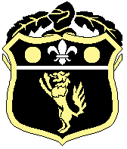
Old Wilsonians Cricket Club

Useful Emergency Contacts

In a dire Emergency for Fire, Ambulance or Police call 999

NHS Urgent Helpline call 111
Call 111 if you need medical help fast but it is not a 999 emergency, or if you think you need to go to A&E or need another urgent care service

Nearest Accident and Emergency Department
The Princess Royal Hospital, Farnborough Common, Orpington BR6 8ND
01689 863 252

Beckenham Beacon Urgent Care Centre
379-397 Croydon Road, Beckenham, BR3 3QL
01689 866 037

Bromley Police Station
High Street, Bromley, BR1 1ER (24 hours)
Call 101

London Fire Brigade Bromley
4 South Street, Bromley, Kent, BR1 1RH
020 8555 1200

